Assignment PYSA Installation:
git clone https://github.com/facebook/pyre-check.git
cd pyre-check/documentation/pysa_tutorial

1. Create & Activate Your Virtual Environment:
# 1. Create a venv named "tutorial"
python3 -m venv tutorial

# 2. Activate it
source tutorial/bin/activate

# 3. Upgrade pip and install the dependencies
pip install --upgrade pip
pip install pyre-check fb-sapp django-stubs

2. Exercise 1: Run Pysa “Out of the Box”
- Enter the exercise1 directory
cd exercise1
- Run the analyzer
pyre analyze
- What you should see
A single JSON issue pointing at views.operate_on_twos.
[
{
"callable": "views.operate_on_twos",
"code": 5001,
"message": "Possible RCE: User specified data may reach a code execution sink",
"filename": "exercise1/views.py",
"line": 5,
…
}
]
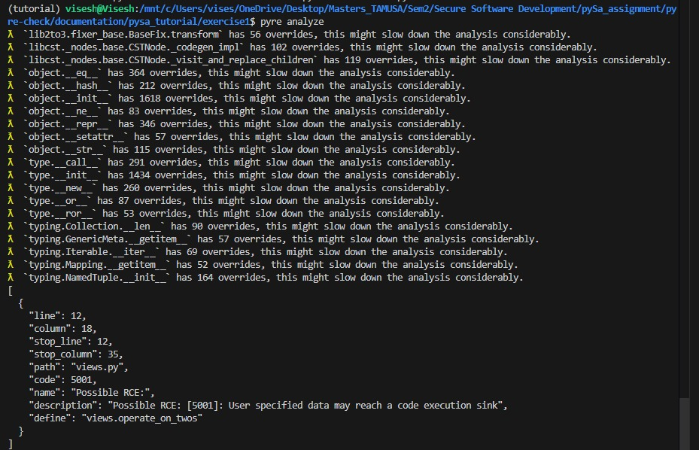
Exercise 2: Pysa New Sources, Sinks & Rules
2.1. Enter exercise2 and confirm zero findings
cd ../exercise2
pyre analyze
# → should report no issues (an empty array or “No issues found”)

2.2. Update sources_sinks.pysa
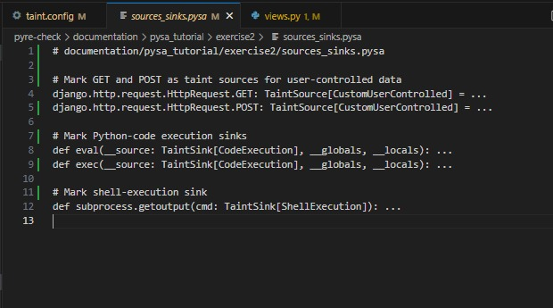
2.3. Update taint.config: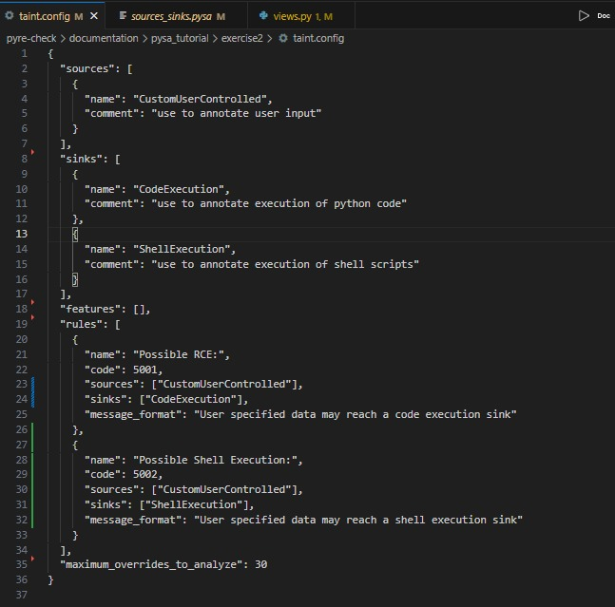

2.4. Verify views.py remains unchanged
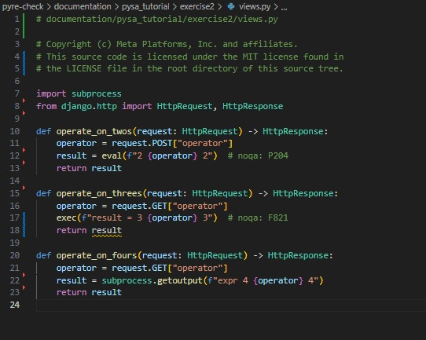
4. Re-run the Analyzer
pyre analyze
You should now see three taint findings:
- POST → eval in operate_on_twos (code 5001)
- GET → exec in operate_on_threes (code 5001)
- GET → subprocess.getoutput in operate_on_fours (code 5002)

OUTPUT:

